**Practical 6**

**(PART – A)**

***Aim: To convert regular expression to NFA and apply pumping lemma.***

**Outcome:** After successfully competing of this practical, students will be able to learn:

* What is regular expression?
* How to convert it?
* How to apply pumping lemma and how it works?

**A.1 Reading**

Read Exp 17 of Lab manual. Page 107 to 117

Read Exp 18 of Lab manual from Page 113 to 125

**A.2 Tasks**

1. Convert the following regular expression to NFA diagram
   1. (a+b)*. A. (a+b)*
   2. (1*.0.1*.0.1*)* + 1*
   3. 0*.1*.2*
2. Apply pumping lemma and show that the following language is a non-regular language.

L= {anbn |n >0}

**PART B**

(PART B: TO BE COMPLETED BY STUDENTS)

**(Students must submit the soft copy as per following segments within two hours of the practical. The soft copy must be uploaded on the Portal or emailed to the concerned lab in charge faculties at the end of the practical in case the there is no portal access available)**

|  |  |
| --- | --- |
| Roll No. A016 | Name: Varun Khadayate |
| Program: B-Tech (CSBS) | Division: SY |
| Batch: B1 | Date of Experiment: 25/8/2020 |
| Date of Submission: 25/8/2020 | Grade: |

**B.1 Output:**

1. Write a procedure to convert regular expression to NFA.

* Select “Regular Expression” in the selection menu.
* Type the expression in the box.
* Then select “Convert to FA” where you can step through the conversion until the automation can be exported to a new window.
* If the automaton is correct it should be possible to convert it back to a regular expression again.

2. Write a procedure to apply pumping lemma.

* Assume L is a regular language so now we can apply Pumping Lemma on L.
* Let us assume N is 6 so we now need a string in L say X > N in the form xyz where x+y<N.
* X = a4b4or aaaabbbbsuch that its length is 8 > N and n = 4. In X we assume x is ‘aaa’ and y is ‘a’, such that x + y = 4 <N.
* Now we pump y such that the string is of the form xy2z = aaaaabbbb = a5b4which is not a part of L, but according to Pumping Lemma it should.
* So we conclude that L= {anbn |n >0} is a non-regular language.

**B.2 Observations/Learning**

*(Students are supposed to write the logic of constructed DFA and generated regular expression)*

1. Convert the following regular expression to NFA diagram
   1. (a+b)*. a. (a+b)*

Ans: 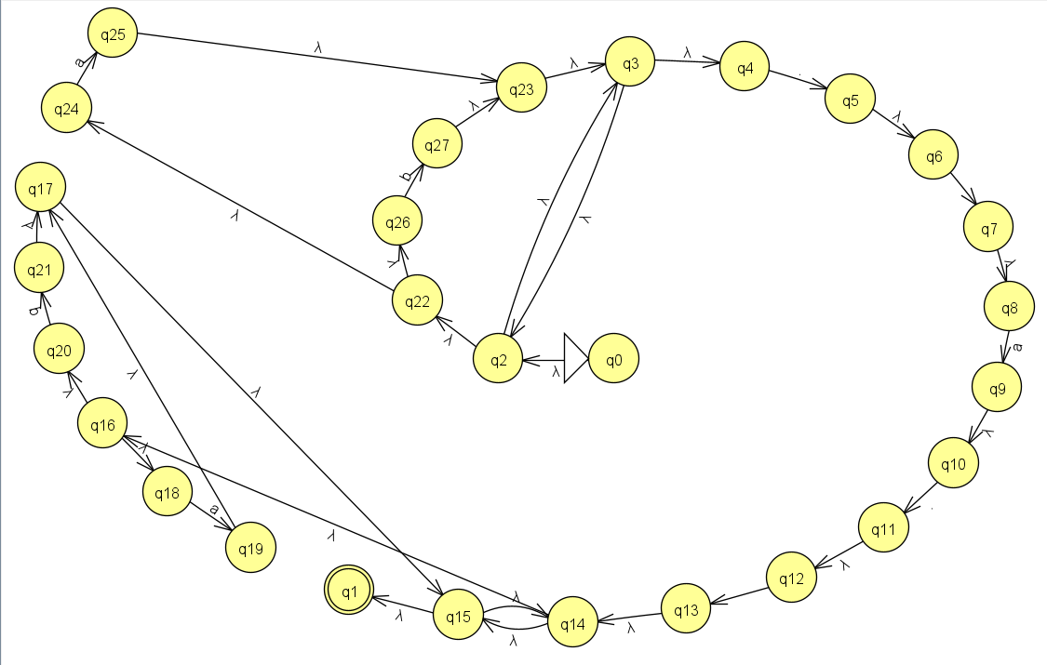

* 1. (1*.0.1*.0.1*) * + 1*

Ans: 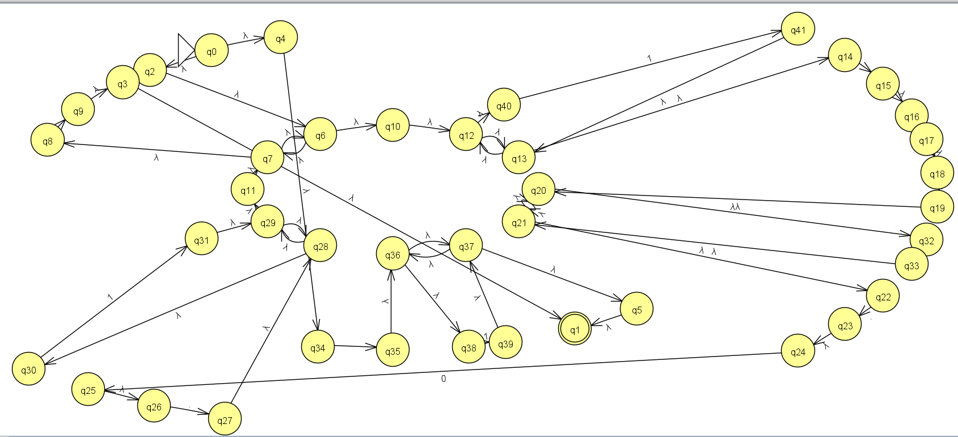

* 1. 0*.1*.2*

Ans: 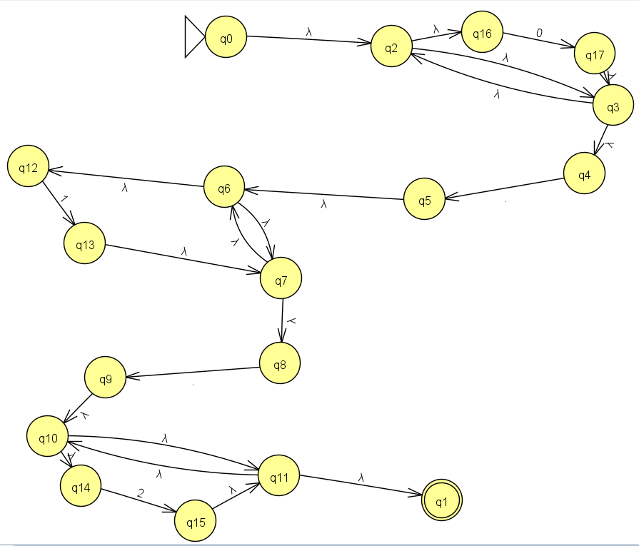

1. Apply pumping lemma and show that the following language is a non-regular language.

L= {anbn |n >0}

Ans: 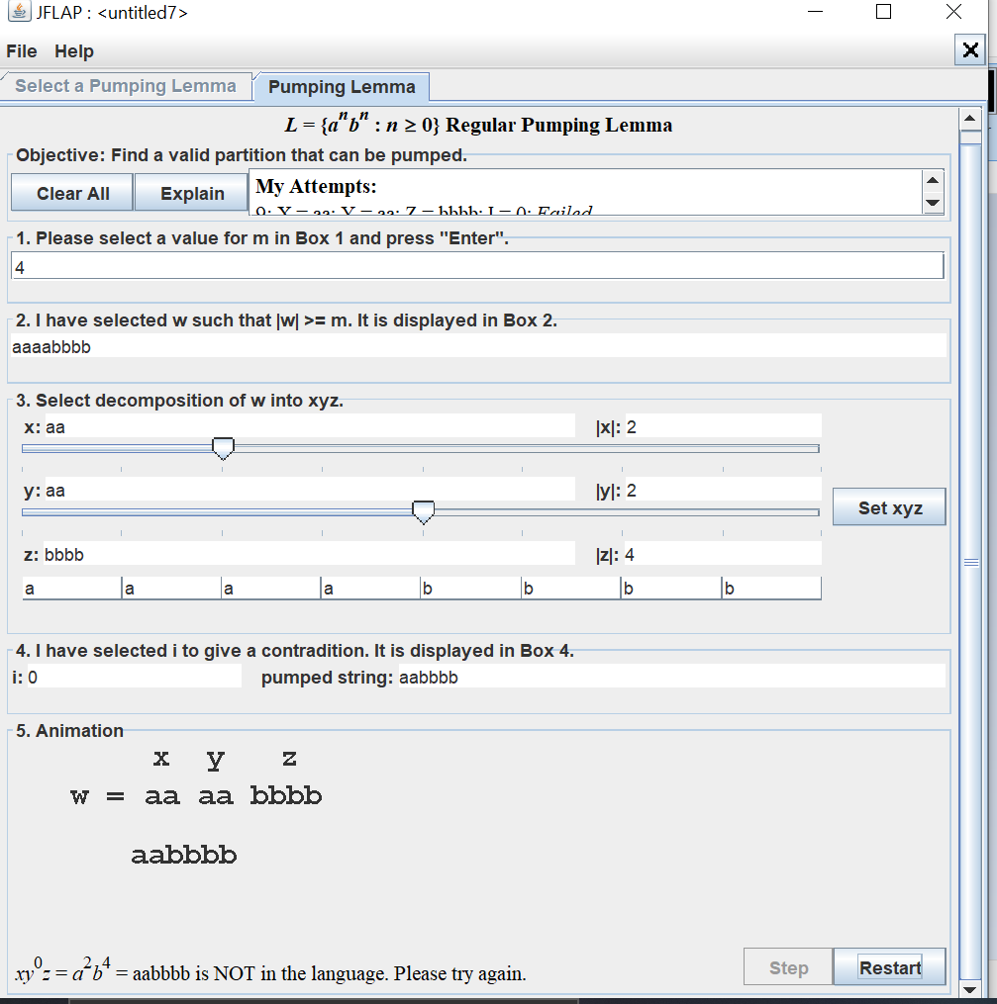

**B.3 Conclusion:**

*(Students must write the conclusion as per the attainment of individual outcomes and learning/observation)*

***B.4 Curiosity Question***

***Can you generate a general formula to find total number of states when positions of particular input is fixed from left hand side? Explain***